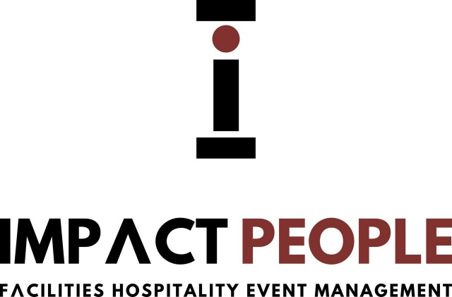

Impact People Management LTD (IPM LTD) recognises that all businesses have an obligation to prevent slavery and human trafficking and will do all in its power to prevent slavery and human trafficking within its business and within the supply chains through which it operates.
Modern slavery can take many forms including the trafficking of people, forced labour, servitude and slavery. As a leading recruitment expert, we take our responsibility for supplying staff extremely seriously and are aware of the potential for being targeted by traffickers and unlicensed gangmasters. Our own processes around candidate engagement ensure our employees are alert to the signs of exploitation, in order that we may take the necessary action promptly and effectively should it be identified. Sectors affected include, but are not limited to, construction & property, engineering & manufacturing and health & social care.
This statement focuses specifically on IPM LTD compliance with the Modern Slavery Act 2015 (the Act) and highlights the steps we take to ensure there is no slavery or human trafficking occurring within the organisation or its supply chains. One of our Company’s most valuable assets has always been its reputation for integrity and fairness. Maintaining this reputation within our market is an essential pre-requisite to our continued success.

Our Policies including on Slavery and Human Trafficking
Employees should be free to choose to work for their employer and to leave the company upon reasonable notice.
All employees must be provided with a clear contract of employment, which complies with local legislation.
All employees must be treated in a fair and equal manner and with dignity and respect.
Any form of discrimination, victimisation or harassment on the grounds of marital or civil partnership status, sex (including gender reassignment), race (including colour, ethnic and national origin, nationality), disability, sexual orientation, having or not having dependants, religious belief or political opinion, age, trade union activity and offending background should be prohibited.
All applicable laws and industry standards on employee wages, benefits, working hours and minimum age should be adhered to in all countries of operation, without any unauthorised deductions. Clients should observe the provisions of the International Labour Organization such that any young persons under the age of 18 should not be employed to work at night or for any hazardous work and their employment should not harm the young person’s education, health or physical, mental, moral or social development. No young persons may be employed below the age of 16.
All slavery and human trafficking laws must be complied with including, but not limited to, the UK Modern Slavery Act 2015. Clients must ensure their business operations are free from slavery and human trafficking practices whether in the UK or elsewhere, both internally and within their supply chains and other external business relationships. We are committed to ensuring that there is no modern slavery or human trafficking in our supply chains or in any part of our business.

Due Diligence Process for Slavery and Human Trafficking
IPM LTD ensure strict compliance checks are carried for all candidates it supplies. We verify the identity of each worker and their right to work before supply commences.
As part of our commitment to identify and eradicate slavery and human trafficking, we have in place a process to undertake due diligence on our supply chain network to ensure compliance with legislative obligations; such compliance forms part of our contractual relationship with Clients.
All IPM LTD employees have access to dedicated channels through which they may voice concerns, either through local reporting mechanisms or through the global whistleblowing procedure. IPM LTD is committed to protecting employees when disclosing malpractice and will ensure that all disclosures made in good faith will be treated confidentially and without fear of retaliation.

Training
All staff within IPM LTD are expected to comply with all laws and act in accordance with local guidelines and regulations and act with integrity and honesty. We have undertaken to review our policies and procedures to ensure our colleagues have access to any additional information and support they may require with regard to human trafficking, forced labour, servitude and slavery.
This statement is made pursuant to Section 54 of the Modern Slavery Act 2015 and constitutes IPM LTD slavery and human trafficking statement in respect of its 2020 financial year.

Signed: HARISH C AGGARWAL
Position: DIRECTOR
Date: 17 JANUARY 2019

